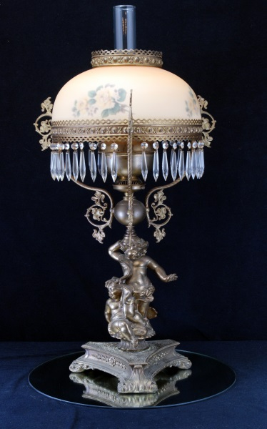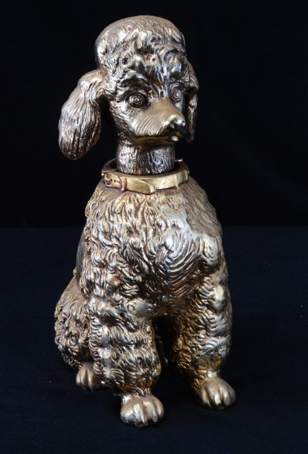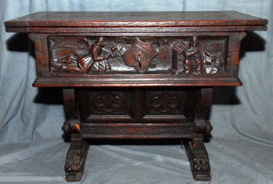

Items Include:

* Ceramics – French (Limoges), Italian (Capodimonte), German, English, Portuguese
* Large Sealife Free Form Centerpiece
* Gothic-Style Game Table
* Pool Table
* Carved & Barley Twist Desk
* Antique French Carved 85” Wide Sideboard
* Poodle Figurines in Various Sizes
* Glass (Cut, Etched, Milkglass, Knife Rests)
* Copper
* Pewter
* Hot Tub
* Art & Tapestries
* Sterling & Silverplate
* Schatz 400 day clock
* Large selection French cookware & cookbooks
* Embossed Vintage Belgian Shield w/Crossed Swords
* Brass & Crystal Chandeliers
* Impressive Banquet Lamp
* Toledo Sword
* La Jurassienne Box
* 1960s Racine Select Yachting Pocket Timer
* Baccarat Cognac Decanter
* Primitives (Cast Iron, Bed Warmer, Sieve)
* Maple Bedroom Furniture

Freeman Estate French Antiques & Collectibles

Live & Internet Auction

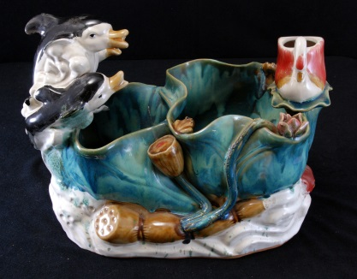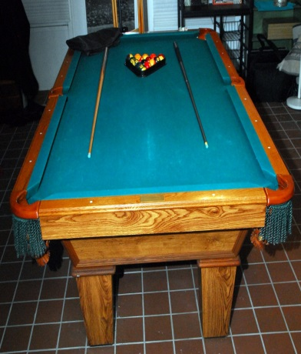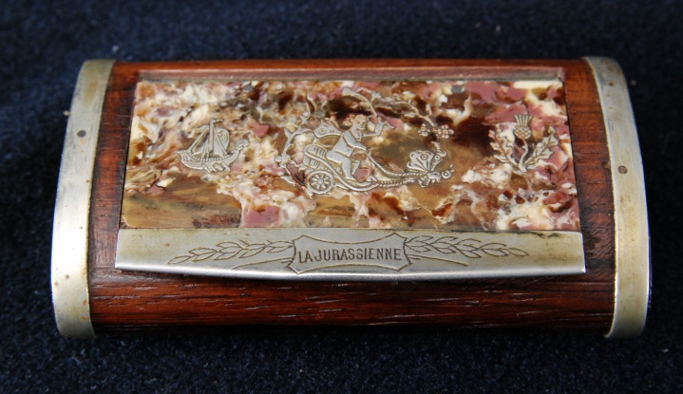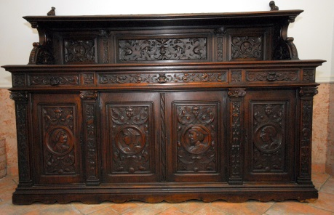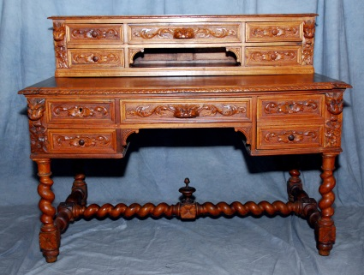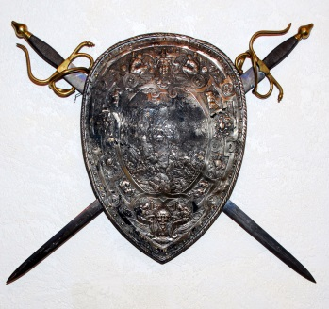

**Live auction Saturday, August 29, 2015**

**at 8 AM CST.**

**Preview and registration at 7.  
  
Internet bidding starts now at www.sospcfl.com!**

**This auction will be held on-site at**

**4801 North Lakewood Drive**

**Panama City, FL 32404**

**Live only pre-auction on Friday,**

**Aug. 28 at 9 AM.**

As Is, Where Is, All Sales Final. Checks/Cash/Credit Cards. Buyer's Premium. Auctioneer AU3226, AB2366, AE426. Tax Exempt Must Present 2015 Certificate.

The Specialists of the South, Inc. 544 E. 6th Street

Panama City, FL 32401. 850-785-2577.