## DARLENE'S BUSINESS CARD

For More Details Please Visit:

[www.auctionzip.com](http://www.auctionzip.com)

[www.paauctioneerbullock.com](http://www.paauctioneerbullock.com)

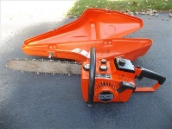

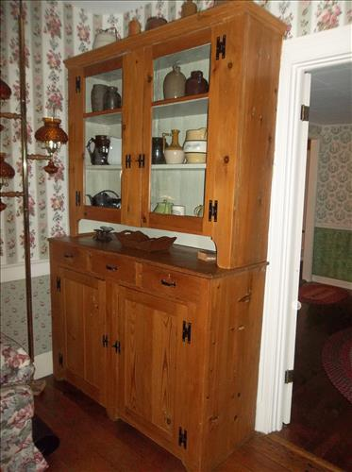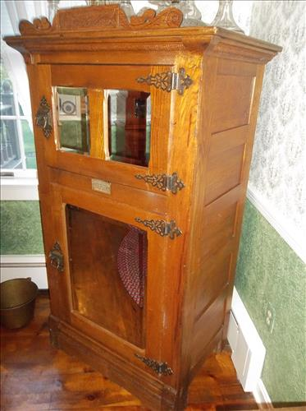

**Antiques & Collectibles:**Copper Boilers, Brass Buckets, Crocks, Crock Jugs, Quilts, 4 - Aladdin Oil Lamps, Many Oil Lamps of Varying Sizes, Shapes & Colors, Finger Oil Lamps, Wall Oil Lamps, Hurricane Lamps, Dough Box, Oat/Flour Box, Coal Scuttles, Standard Treadle Sewing Machine, Large Copper Kettle w/Stand, Footed Cast Iron Kettles, Wedgewood Ironstone, Hoosier Jars, Watt Ware Banded Bowl & Soup Bowls, Fiesta Cobalt Platter, Hand Blown Crackle Glass, Flash Glass, Moon Stone, Ruby Red, Lead Crystal Glass, Fostoria, Fenton, Westmoreland, Lenox Teapot & Vase, Candlewick, Cruets, Bristol Vases, Roseville Pitcher, Hall Teapot, Stangl, Herend, Homer Laughlin, Musket Gun, Powder Horns, Wood Staved Buckets, Fluted Cranberry Oil Lamp Shade, Hens on Nest, Chicken & Rooster Collection, Salt & Pepper Collection, Brass Hand Bells, Wendell August Forge Items, Cast Iron Amish & Chicken Door Stop, Collector Spoons, Enamelware, Keys, Hummel Bells, Goebel Gnomes, Cameras, Miniature Steiff Bears, Ladies Hats & Linens, Buggy Gas Lights, Griswold #10 Griddle, Cast Iron Wagner Skillets, Hand Stitched/Needle Work Linens, Lace Tablecloth & Dollies, Metal Flat Top Trunk, Many Vintage Books & A Lot More...                

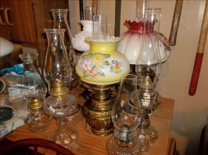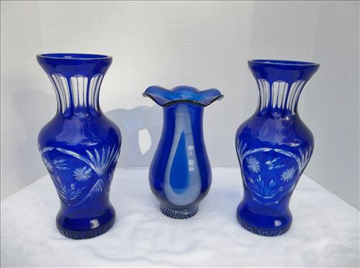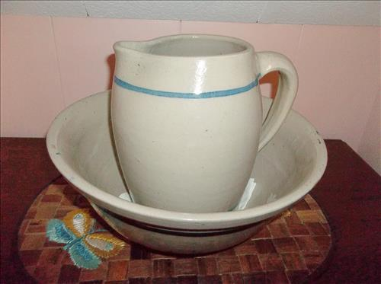**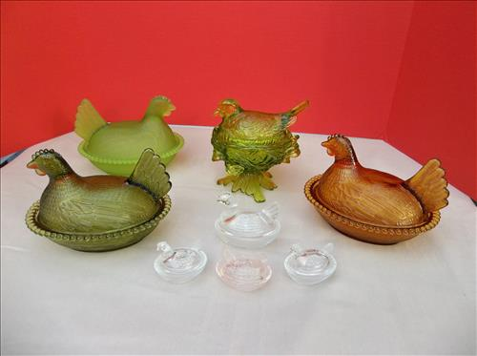Vintage Furniture:** Hitchcock Drop Leaf Table & 5 Chairs, Armoire,Claw & Ball Foot Piano Stool, Antique Glove Box Dresser w/Mirror, Dresser w/Harp Mirror, Lane Cedar Chest, 4 Drawer Serpentine Dresser, Eastlake Parlor Table & Mirror, Wash Tub Stand, Knotty Pine Step Back Cupboard, Claw Foot Curved Glass Curio Cabinet, Primitive Side Stands, Wood Lift Top Commode, Wash Stand w/Towel Rack, Barrister Bookcase, Piano Desk, Marble Top Parlor Table, Spindle Leg & Cherry Single Drawer Side Tables, Jelly Cupboard, Wing Back Chairs, Knee Hole Desk, Church Pew, Marble Top Eastlake 3 Drawer Dresser, Day Bed, Oak Office Chairs, Stools, Deacon Bench, Hand Painted Bed Stool, Primitive Bench, Corner Table/Desk, Wood Tea Cart, Dry Sink, Wood Ice Chest w/Bevelled Mirrors, Wood Lift Top Box, Small Wood Chest, Plank Bottom & Ladder Back Chairs, Wood High Chair, Blanket Box & Chest, Dry Sink & More

**Furniture:** La - Z - Boy Recliner, Wesley Hall 3 Cushion Sofa, Matching Recliner & Sofa, Outdoor Patio Furniture, Glass Front Library Bookcase, 2 Book Shelves, Computer Desk, Office Chairs, 6 Drawer Cherry Dresser w/Mirror, 5 Drawer Cherry High Boy Dresser, Thomasville Hide-A-Bed, Pine Side Stand, Maple Rocker, Drop Leaf Table, Dining Room Suite: Table w/5 leaves, 6 Chairs, Buffet & China Cupboard; SRU Black Rocker, Upholstered Chair & More..

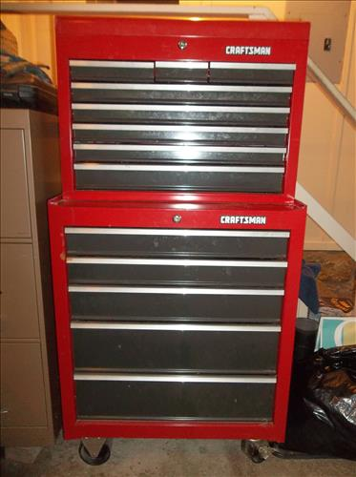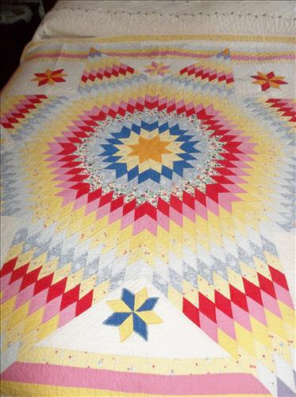**Coins:**Silver Coins:  Morgan & Peace Dollars, Washington & Standing Liberty Quarters, Kennedy & Walking Liberty Halves & 40% Silver Kennedy Halves; South African Coins & Foreign Coins; 

**Tools & Equipment:**  Troy-Bilt Rear Tine Rototiller, Electric Toro Blower, Poulan Gas Blower, Shindaiwa Weed Eater, Electric Toro Weed Eater, B & D Hedge Hog, Husky Pressure Washer, Echo 16" Chain Saw, Push Mower, Wheelbarrow, Lawn Cart, Craftsman Tool Chest, Scott & Green Thumb Seeders, Bench Vise, Craftsman Belt/Disk Sander, Bar Clamps, Garden Tools & More

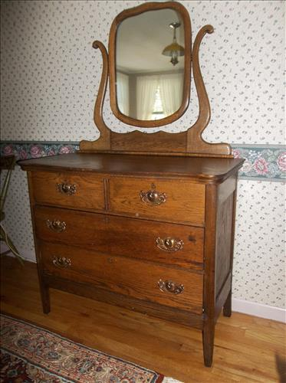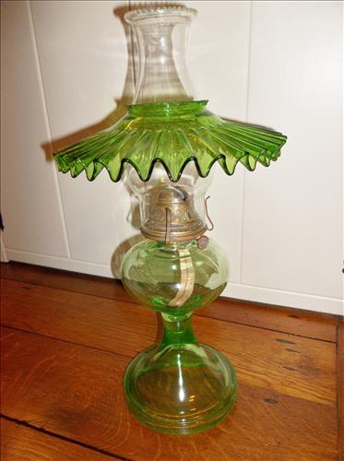**Household Items & Other Misc:**40" Samsung Flatscreen TV & Stand, Bose Alarm Clock/Radio, Stiffel Lamps, Stainless Steel Stock Pots, Ducane Gas Grill, Camping Chairs, Galvanized Garbage Cans, Bird Bath, Gas Cans, Presto Griddle, Cuisinart Coffee Maker, 22 Qt. Pressure Cooker, Oster Bread Maker, Gun Cleaning Materials & Ammo, Canning Jars, Metal Cabinets, Tarps, Wall Mirrors, Metal File Cabinet, Paper Shredder, Card Tables & More..

**Items of Interest:** Winchester 22 Cal. Model 67A,  Mossberg 20 Ga Accu-Choke, Live Traps, Black Walnut Boards, Schwinn & GT Mountain Bikes, Schwinn Weight Lifting Station, Women's Golf Clubs, South African Drum, Oriental Area Rugs, Many Painting & Prints and Much More ....

**Owners: Anne Griffiths & Pat Zimmerman**

**CALL Darlene Bullock –Auctioneer AU005406-L**

**At 724-372-1066 for more info!**