| July 15, 2017 Live & Internet Estate Auction  Preview & Register at 7 AM CST, 8 AM Start |  |  |  |
| --- | --- | --- | --- |

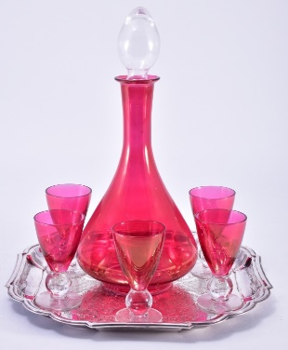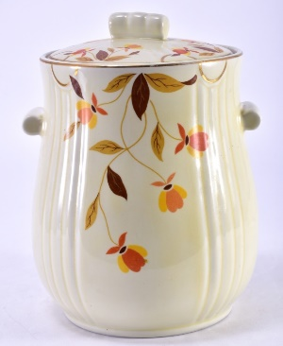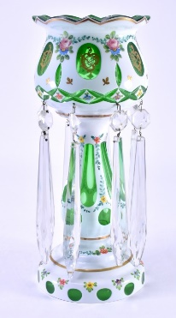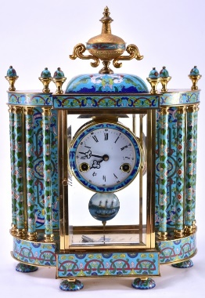

Preview week of auction Monday through Friday,

9 AM to 4 PM.

**Bid online now at www.sospcfl.com!**

* 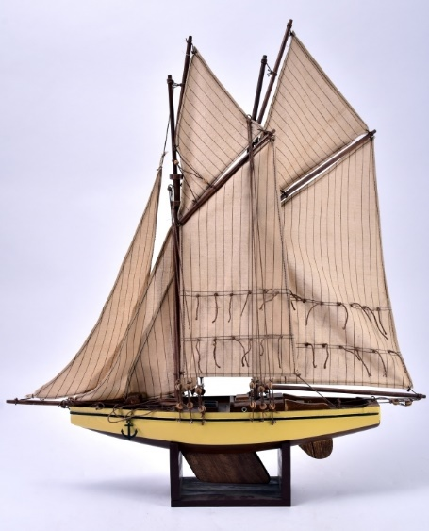Royal Worcester Evesham English Dinnerware
* Crystal & Cut Glass
* Figural Lamps
* Broyhill Furniture
* Artwork
* Estate Jewelry
* US Mint Proof Sets & Other Coins
* Pfaff Sewing Machine & Oversize Cabinet
* Clocks & Mirrors
* Orientalia
* Christmas Houses & Vintage Decorations

The Specialists of the South, Inc.

544 E. 6th Street

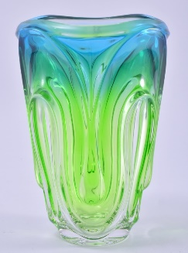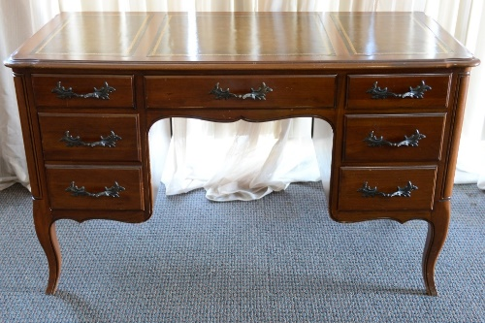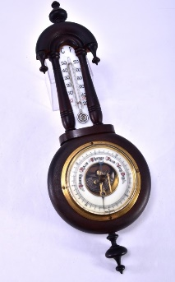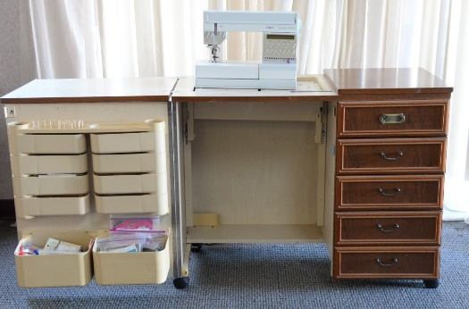Panama City, FL 32401

As Is, Where Is, All Sales Final. Checks/Cash/Credit Cards. Buyer's Premium, Auctioneer AU3226, AB2366, AE426.

Tax Exempt Must Present 2017 Certificate.

**The Specialists of the South, Inc. 544 E. 6th Street, Panama City, FL 32401. 850-785-2577.**

Questions on consigning for an auction or bidding? Contact us at auctions@sospcfl.com.