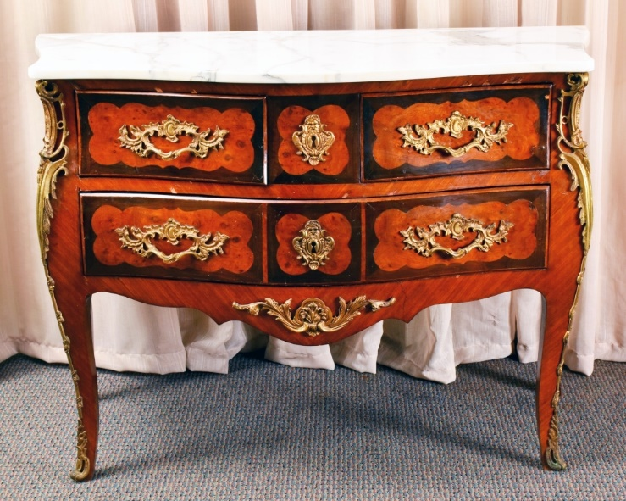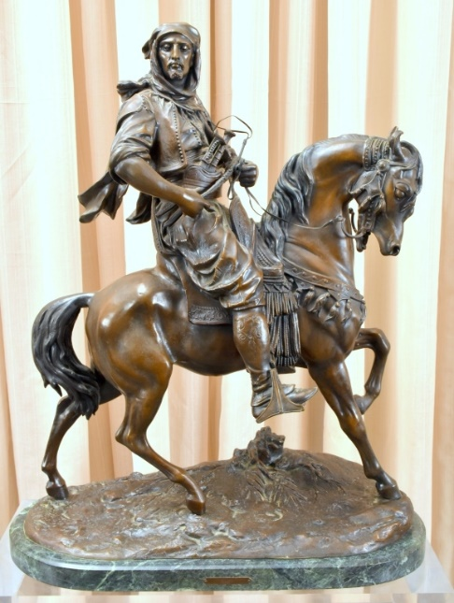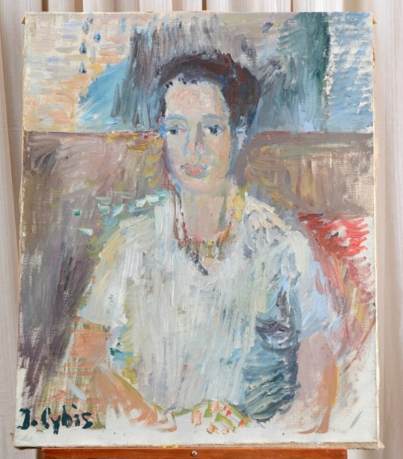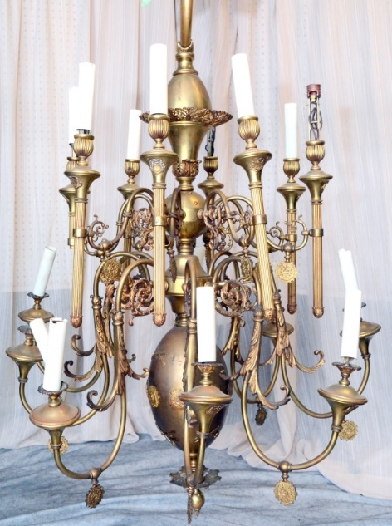

Featured Items Include:

* Barye bronze
* Antique Clocks
* louis xiv-style furniture
* Silver
* large crystal Chandeliers
* cut glass, inc. Waterford
* Porcelain & ceramics
* Lamps & MIrrors
* ornate picture frames
* orientalia
* primitives
* Artwork, Inc. Polish Artists Jan Cybis, jacek polak & mieczyslaw wejman
* and much more from an alexandria, va antique shop!

As Is, Where Is, All Sales Final. Checks/Cash/Credit Cards. Buyer's Premium, Auctioneer AU3226, AB2366, AE426.

Tax Exempt Must Present 2018 Certificate.

**The Specialists of the South, Inc. 544 E. 6th Street, Panama City, FL 32401. 850-785-2577.**

Questions on consigning for an auction or bidding? Contact us at auctions@sospcfl.com.

**July 7, 2018 – Notable Art, French-Style Furniture & More Live & Internet Estate Auction**

8 AM CST Start, Preview & Registration at 7 AM

Preview week of auction Monday to Friday, 9 AM to 4 PM

The Specialists of the South, Inc.

544 E. 6th Street • Panama City, FL 32401

**Bid Online Now at www.sospcfl.com**